**Dockerize Applications**

**Note (Update My App Repo Link)**

[**https://github.com/elgooohary/MoneyApp**](https://github.com/elgooohary/MoneyApp)

1. **Create Docker file from backend.**

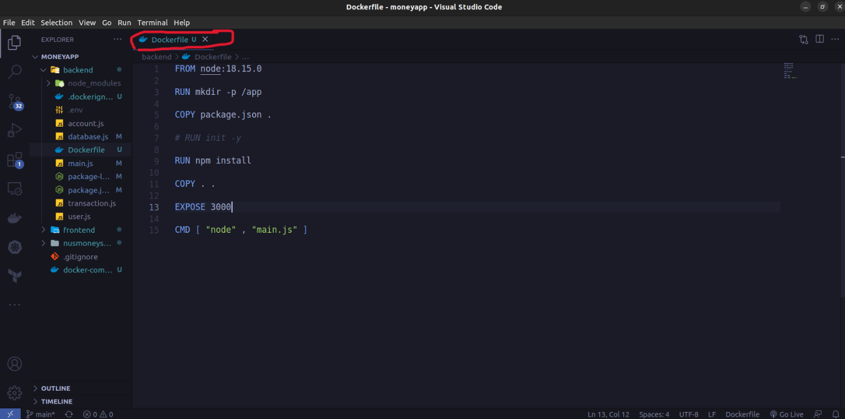

1. **Create Docker file from Frontend.**

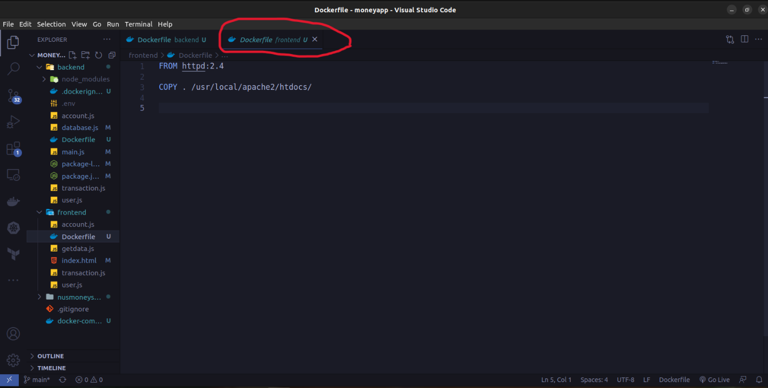

1. **Create Docker compose to run backend and frontend app.**

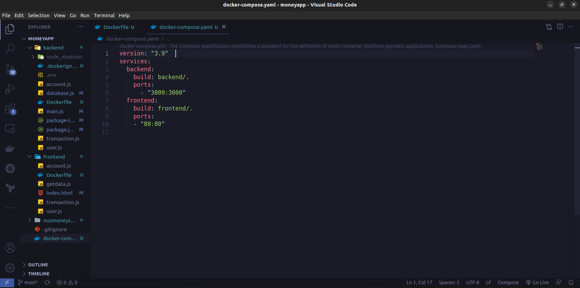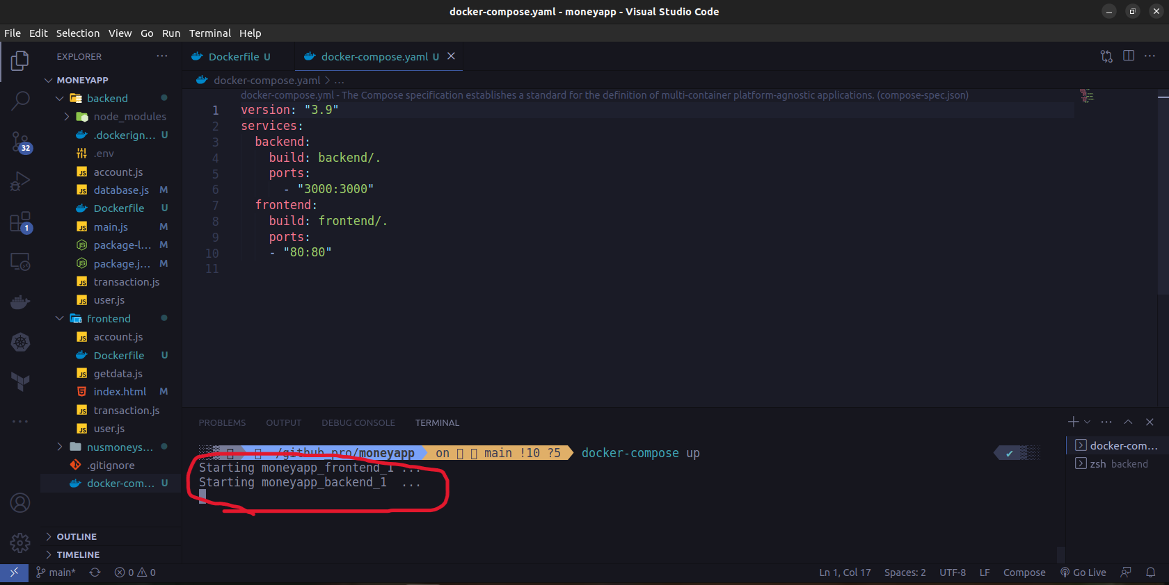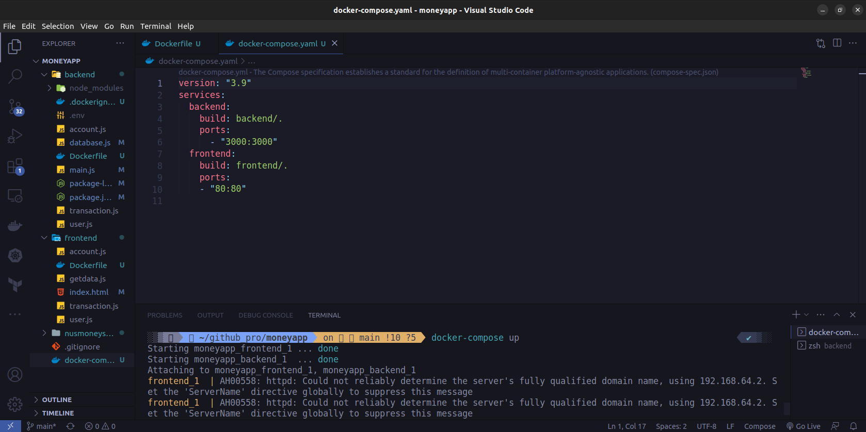

1. **Pull image (postgres)**

